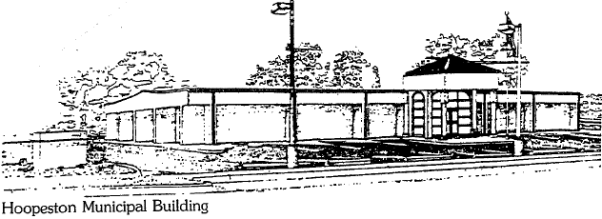
City of Hoopeston
301 W Main St
Hoopeston, IL 60942
217-283-5833

Notes:
- Attending - Mayor, Chad, Robin, Bill G, Alex, Joel S
- Access system now stalled at Cemetery office - also being tested as time clock. System to be installed at Park office in the coming weeks. Cost around $800 for each.
- Committee approved City Hall access system with already budgeted and approved $11k. Will present quote to council for final approval.
- Bullet proof glass - acknowledged the office employees want glass installed. Moving forward with this by getting additional quotes/proposals. Will request to fund this on the upcoming budget (estimating $16k). Decided to do access system before glass because the time it'll take to implement glass- pushing it to next fiscals year's budget anyway.
Actions:
Dawn - Add City Hall access system approval to 1/21 agenda.
Alex - Present Joel S quote to council for approval 1/21.
Mayor - Work with Tom B to get additional glass quotes/proposals.
Joel S - Send Alex digital version of quote and map.
Joel S/Mayor/Carl - Approve police dept access system layout with chief.

Alex Houmes
Ward III Alderman | City of Hoopeston

