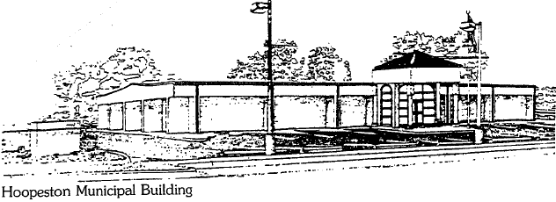
City of Hoopeston
301 W Main St
Hoopeston, IL 60942
217-283-5833

Called to order 6:00 pm
Attending : Joel Bird, Troy Stevens, Alex Houmes, Bill Goodwin, Lourdine Florek, Carl Ankenbrand, Mayor Bill Crusenberry and Robin Lawson.
Discussion of revisions of 3 ordinances.
2.34.060....qualification and retirement
2.36.010.... fees for fire calls
15.12.050... redefining fire zone.
Discussed upcoming budget.
Adjourned 7:05pm

Robin Lawson
Ward IIII Alderwoman | City of Hoopeston

