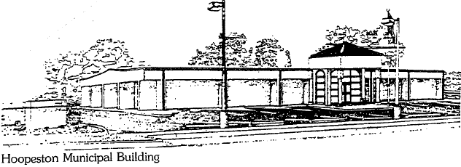
City of Hoopeston
301 W Main St
Hoopeston, IL 60942
217-283-5833

Park dept meeting - 2/11/2020, 7pm
Attending: Bill Goodwine, Carl Ankenbrand, Chad Yaden, Mayor, Joel Schuler, Brad Hardcastle, Alex Houmes
EMA/Aux building - discussed in length their build proposal. If funds are approved, park Committee agreed for building to be constructed on NW corner of annex property instead inside main park.
2020 budget - agreed to request the follow at budget meeting:
Park - $18k for lagoon project
Civic Center - new entry door with access system, kitchen improvements, and security cameras. Getting estimates on these.
Adjourn
Alex Houmes
Ward III Alderman | City of Hoopeston

