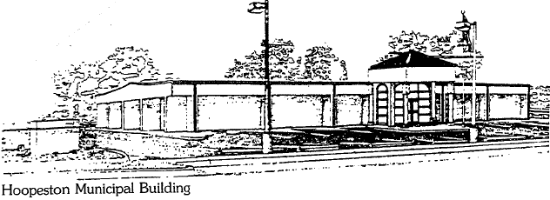
City of Hoopeston
301 W Main St
Hoopeston, IL 60942
217-283-5833

Security Committee Meeting minutes

2/25/20 7pm

Attending: Dawn Layden, Alex Houmes, Mayor, Robin Lawson, Chad Yaden, Joel Schuler

- Discussed proposed policy for managing the new access system. A few revisions were suggested, Dawn is going to make those changes and committee will present to council for approval.
- Reviewed and approved the list of who will have access to what area. Joel will use this for initial implementation.

Adjourned 7:58 pm.

Alex Houmes
Ward III Alderman | City of Hoopeston

