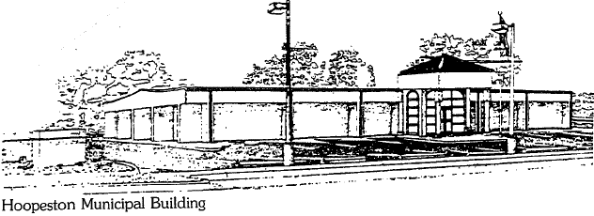
City of Hoopeston
301 W Main St
Hoopeston, IL 60942
217-283-5833

ATTENTION

The City Clerk will be accepting petitions from those who are running for public offices at City Hall, 301 W. Main St.

DATES AND TIMES

Monday, December 14th, 2020 8:30-11:30 AM
Wednesday, December 16th, 2020 8:30-11:30 AM
Friday, December 18th, 2020 8:30-11:30 AM
Monday, December 21st, 2020 8:30-11:30 AM
Tuesday, December 22nd, 2020 8:30-11:30 AM

If you are unable to bring your petition during these hours, please contact City Hall at 217-283-5833 or mail your petition to City Clerk at 301 W. Main St.

