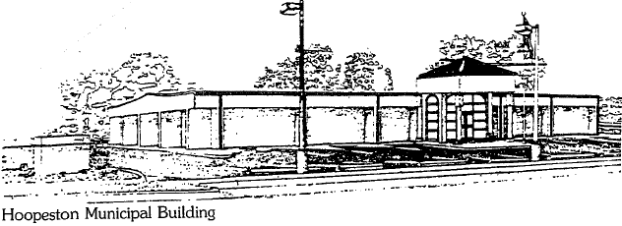
City of Hoopeston – Floral Hill Cemetery 301 W Main St. Hoopeston, IL 60942
217-283-5833 217-283-6311

POLICY FOR FLORAL HILL CEMETERY

- STAY OFF GRASS. PARK ON ROADS ONLY AT ALL TIMES. NO UNLICENSED VEHICLES, ATV’S, DIRTBIKES, OR SKATEBOARDS ALLOWED IN CEMETERY.
- NO PLANTING OF TREES, SHRUBS, BUSHES, FLOWERS, ETC.
- NO BORDERING OF GRAVES WITH METAL FRAMES, CRUSHED STONE, FENCES, OR OTHER MATERIAL NOT PERMITTED.
- NO PLACING BOXES, SHELLS, TOYS, METAL DESIGNS, FRAMES, ORNAMENTS, CHAIRS, SETTEES, WOOD OR IRON CASES, GLASS, ANYTHING BREAKABLE, OR ANY OTHER ARTICLES UPON LOTS AND/OR MONUMENTS.
- FLOWERS TO BE PLANTED IN URNS OR HANGING BASKETS. NO COVERING FULL OR PARTIAL GRAVESITE WITH FLOWERS OR ANY WITH OTHER MATERIAL.
- GRAVE BLANKETS, HALF BLANKETS, WREATHS, AND BOUQUETS ARE ALLOWED DURING NON-MOWING SEASON AND MUST HAVE PLASTIC SPIKES. NO METAL SPIKES.
- ARTIFICIAL DECORATIONS AND FLOWERS ARE PERMITTED IN METAL OR PLASTIC VASES. SADDLES ARE ALLOWED TO BE PLACED ON STONES. NO GLASS ALLOWED AND NO FLOWERS TO BE STUCK IN THE GROUND.
- FOR MAINTENANCE PURPOSES, DECORATIONS MUST BE REMOVED AS FOLLOWS: WINTER DECORATIONS – FIRST MONDAY IN MARCH
SPRING & SUMMER DECORATIONS – THIRD MONDAY IN SEPTEMBER
- THE CITY CANNOT GUARANTEE DECORATIONS FROM DAMAGE OR DISAPPEARANCE.
- FOOTSTONES ALLOWED BUT MUST BE FLUSH WITH THE GROUND AND INSTALLED BY A PROFESSIONAL UPON APPROVAL BY CEMETERY MANAGEMENT.
- BENCHES ALLOWED AS PART OF MEMORIAL AND MUST BE APPROVED BY CEMETERY MANAGEMENT.
- NO DOG WALKING OR RUNNING OF DOGS ALLOWED IN CEMETERY.
- VAULTS ARE REQUIRED FOR ALL BURIALS.
- CEMETERY IS OPEN FROM DAWN TO DUSK.

