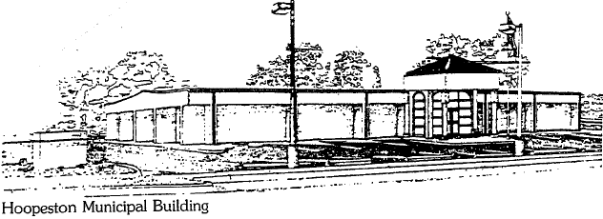
City of Hoopeston
301 W Main St
Hoopeston, IL 60942
217-283-5833

PERPETUAL CARE BID SPECIFICATIONS

The Floral Hill Cemetery is now accepting bids for the planting of live flowers for 117 urns and 10 large flowerpots for the 2021 perpetual care planting. The total of 127 urns are to be planted with hardy flowers and greenery that are evenly spaced throughout the urn. The flowers and greenery must fill out the urn and bloom throughout the Spring, Summer, and early Fall.

Bids are due by 9 am Friday, March 26, 2021 and will be opened at 10:00 AM that same day at the City Municipal Building, 301 W Main St. Hoopeston.

They must be planted and growing by Monday, April 26, 2021. We will place the urns at the gravesites after they are planted. We will pick up within one mile if you plant at your business.

The City reserves the right to reject any and all bids and to waive technicalities in bidding.

CITY OF HOOPESTON
CEMETERY DEPARTMENT

