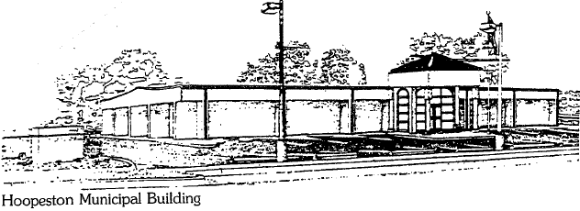
City of Hoopeston
301 W Main St
Hoopeston, IL 60942
217-283-5833

CHAPEL RENTAL CONTRACT

The City of Hoopeston, herin after called the “Landlord”, and ___________________________, herin after called the “Tenant”, agree that the landlord hereby rents to the tenant, on ____________________, the Chapel located in Floral Hill Cemetery, Hoopeston, Illinois.

In consideration of the mutual covenants and after approval of Cemetery Management, both parties agree as follows:

- Tenant agrees to pay the Landlord, at least two (2) weeks prior to the first day of use, at the Administration Office, rent for the use of the premises at the rate agreed, by initialing below.

- _______ - Two Hundred Dollar ($200.00) rental fee per event, per day for non-profit clubs or organizations, charitable events, recreational uses or other activities approved by Cemetery Management for this rate, on the basis of general benefit to the community.

- It is understood that the Landlord does not furnish janitorial services or supplies, that shall be the tenant’s sole responsibility. The building and the premises shall be left in as good an order as they were before the rental period. Including, but not limited to the setting and re-setting of the temperature on the air conditioning or heating units. If any itema(s) that have been moved or used, it must be cleaned and put back in its original spot. Also, any item the tenant has brought in to use for their rental period must be removed that day. Leaving items can interfere in the next rental period. Failure to comply with any of the items listed, the tenant’s deposit will be forfeited. Clean-up must be completed immediately following use or deposit will be forfeited.

- The Landlord reserves the right to randomly inspect the activity to make sure all rules are followed. The tenant assumes total responsibility for control of the tenant’s invitees and violation of this contract by either tenant or tenant’s invitee may result in immediate eviction and forfeiture of all payments made. The City takes no responsibility for any actions, incidents or injuries arising out of this lease. Nor will the City of Hoopeston be held liable for any lost or stolen items.

- The use of the Chapel building must be concluded by dusk that day. The tenant and all of the tenant’s invitees shall depart from the cemetery premises as soon as possible thereafter.

- The Landlord will not be responsible to furnishing any tables or chairs.

- A separate deposit in the amount of two hundred dollars ($200.00) must be made at the time of reservation. The Landlord will return this deposit after inspection of the building is complete, all keys are returned to the City of Hoopeston Administration Office and only if this agreement has been fully complied with. However, the tenant will forfeit the deposit, if the tenant is in violation of the agreement on any matter listed.

- This agreement may be cancelled by the tenant up to five (5) days prior to the event scheduled on page one (1) of this contract without charge. If event is cancelled less than the five (5) days prior or a no-show the day of rental period, there will be no refund issued for the rental fee.

- No alcoholic beverages are allowed in the Chapel building or on the premises of Floral Hill Cemetery at any time and no smoking will be allowed in the building at any time during the rental period or otherwise.

- All Floral Hill Cemetery Rules and Regulations adopted by the City of Hoopeston must be followed while on the premises.

Entered into this _______ day of ______________________, 20 _____.

___________________________________ City of Hoopeston/Municipal Corporation
Tenant Name (print) Landlord

___________________________________ 301 W Main St
Tenant Address Hoopeston, IL 60942

___________________________________ 217-283-5833
Contact Phone Number www.cityofhoopeston.com

___________________________________
Tenant Signature ____________________________________
Signature of City Representative

EVENT DATE: ________________

