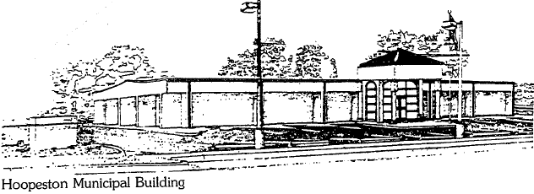
City of Hoopeston
Bulk Garbage Drop Off
LOCATED AT CITY HALL
301 W Main, 283-5833

1ST & 3RD Saturday
of each month
7:30 – 10:30 AM
Must present photo ID with current Street Address

BULK GARBAGE ONLY!
Limited to ONE load and must unload yourself.
NO DUMPING:
Electronics, appliances, paint, liquids, tires, batteries, yard waste, construction/demolition material, or anything that fits in the provided blue tote.

Apartments with a dumpster, Businesses, and Contractors are NOT allowed to dump.

