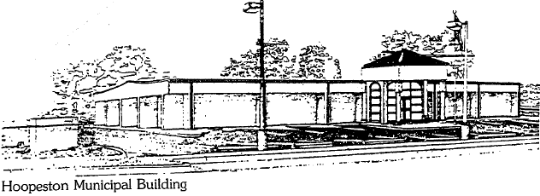
City of Hoopeston
301 W Main St
Hoopeston, IL 60942
217-283-5833

The City of Hoopeston is seeking sealed bids for the sale of 2 lots located at 105 E Main St. and 107 E Main St. The bidder is required to include a monetary bid and the specific intended use of the property. Bid specs can be obtained from the Administration Office at City Hall, 301 W. Main St. Bids are due by Friday, August 12th, 2022 at 9:00 am. Bid openings will be held at City Hall at 9:00 am on Friday, August 12th, 2022.
Thank you,
Gail Lane,
City Clerk

Publication Dates:
Wednesday, July 27, 2022
Wednesday, August 3, 2022

