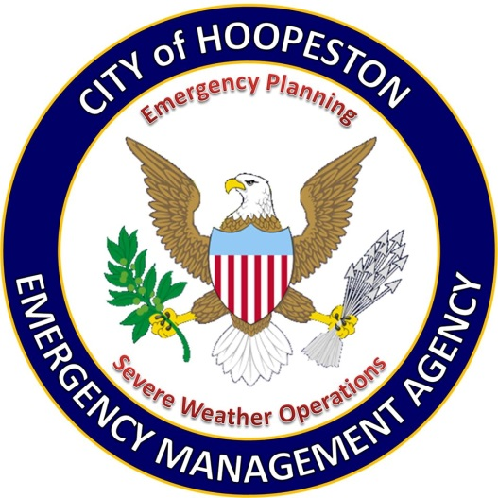
HOOPESTON EMERGENCY
MANAGEMENT AGENCY
413 West Main Street
Hoopeston, Illinois 60942

bradhardcastle@cityofhoopeston.com
www.cityofhoopeston.com

Brad Hardcastle, Director

The Hoopeston Emergency Management Agency is the city agency tasked with the strategic organization of the management process used to protect critical assets and the citizens of the City of Hoopeston from hazardous risks that can cause disasters or catastrophic events and to ensure the continuance of operations of city government. Director Brad Hardcastle and the EMA volunteers and spotters handle severe weather operations and emergency planning for the City of Hoopeston. The Hoopeston EMA has been recognized as a participant in the Great American Shake-up Program and received an award as a Storm Ready Community. The volunteers spend countless hours educating the community and students on how to prepare for emergencies.

Emergencies can happen with little to no advance notice, you may need to evacuate quickly and may not have time to gather or shop for supplies. It is recommended that you create one or more emergency kits in advance of a crisis that includes enough supplies for at least three days for each family member. If you live in a disaster-prone area (hurricanes, floods, tornados or earthquakes) consider extending that to five days per person. Such disasters may interfere with normal supplies of food, water, heat and other day to day necessities. These kits will enable you and your family to respond to an emergency quickly and will be useful whether you have to shelter in place or evacuate. Throughout the year, your kit(s) should expand or evolve depending on your family’s needs, the season and or situation. You should also replace the water supply and any food that may have reached it’s used by or expiration date. An easy way to remember is to use Daylight savings time so that when you change your clocks you also update your kits.

An emergency supply kit should include the following:
• A battery powered radio, weather radio and flashlights, with extra batteries
• Bottled drinking water: one gallon per day per person with at least a three-day supply for each person in your household
• At least a three-day supply of canned or sealed foods that do not require refrigeration or cooking
• First-aid kit and manual
• Non-electric can opener and utility knife
• Mess kits
• Paper towels, toilet paper, soap and detergent
• Household laundry bleach (unscented)
• A blanket or sleeping bag for each member of the family
• One change of clothing and footwear per person
• Fire extinguisher
• Shut-off wrench, to turn off household gas and water
• Signal flare, matches and whistle
• Cell phone and extra battery
• An extra set of car keys, credit card and cash
• A list of family physicians
• Medications or special foods needed by family members such as insulin, heart medication, dietetic food and baby food. Do not store these items in your kit for a long period of time but add at the last minute.
• If needed, formula, diapers and bottles
• Denture needs, extra eye glasses and contact lens supplies
• You can store additional water by filling bathtubs and sinks with water if an emergency is declared. Clean water is also available in toilet tanks, presuming chemicals and other cleaning agents are not used in the water tank.

If you have pets, include the following items in your kit:
• Identification collar and rabies tag
• Pet carrier or cage
• Leash
• Medications
• Newspaper, litter and trash bags for waste
• Two-week supply of food and water
• Veterinary records (necessary if your pet has to go to a shelter)

**The list of suggested items for your emergency supply kit provided by the State of Illinois Emergency Management Agency**

Sources of Weather and Weather Safety Information
For additional information on severe weather or other hazards, contact the following:
• Your local Emergency Management Agency (EMA/ESDA)
• Your local chapter of the American Red Cross (ARC) or www.redcross.org
• State of Illinois: www.ready.illinois.gov
• The nearest office of the National Weather Service (NWS)
• National Weather Service Forecast Office websites:

Davenport, IA www.weather.gov/davenport
Romeoville, IL www.weather.gov/chicago
Lincoln, IL www.weather.gov/lincoln
St. Louis, MO www.weather.gov/stlouis
Paducah, KY www.weather.gov/paducah

