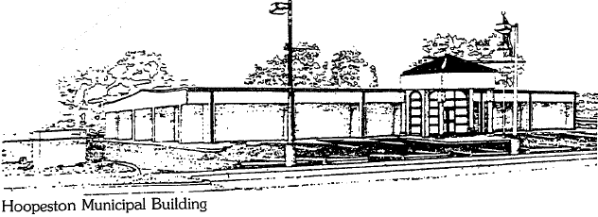
City of Hoopeston
301 W Main St
Hoopeston, IL 60942
217-283-5833

LEGAL NOTICE:

The City of Hoopeston will be conducting a Public Hearing on Tuesday, October 3rd, 2023 at 6:30 PM in City Hall, 301 W Main St., to discuss water and sewer rate adjustments and commercial dumping rates. The rate adjustments and changes will be voted on at the regular City Council meeting on Tuesday, October 3rd, 2023 beginning at 7 PM in City Hall.
Gail Lane, City Clerk

