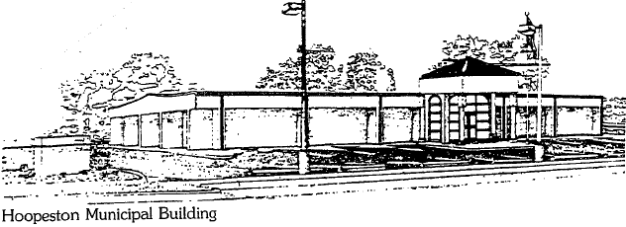
City of Hoopeston
301 W Main St
Hoopeston, IL 60942
217-283-5833

PLANNING COMMISSION MINUTES: 12/13/2023

City of Hoopeston Plan Commission meeting was called to order by Chairman Cody Moore at 6 :05 PM.
Roll call was taken. All members present except Charlene Ervin.

Minutes of previous meeting were read by Loni Gress. No additions or deletions noted. Shawn Swartzentruber made a motion to accept seconded by Eric Zorns. All members voted Aye.

Purpose of this meeting was to allow owners of Vermilion Iron to divide the former industry site from the Little League Fields. Loni Gress made a motion to forward this to the City Council with the plan Commission being in favor of allowing this. Second by Shawn Swartzentruber. Roll call vote taken with all members in favor.

Motion to adjourn by Eric Zorns, second by Shawn Swartzentruber. Meeting adjourned at 6:12 pm.

